**Estes Valley Community Garden (EVCG)**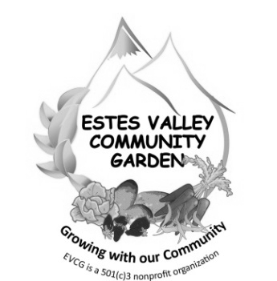

**Application for a 2024 Garden Plot**

I, _, hereby apply for a garden plot.

(Please print)

I understand my name will be placed on a waiting list. The receipt date of this signed application will be the waiting list date, which will be used to determine the order of the list. First come, first served.

When a plot becomes available, I understand ***I will be notified with a Gardener Contract form, and that I will have two (2) weeks to return the signed contract with payment.***

The fee for a 40 square-foot plot (10 ft. x 4 ft.) is $80.00. Rising costs of water, wood, supplies for repairs, and soil products have increased the annual plot cost, forcing us to increase the annual fee.

I would be interested in a tall, raised garden plot (if available). yes_____ no_____

I qualify for a free plot as indicated in this guideline: yes_____ no _____

Household of five: annual income of not more than $70,620

Household of four: annual income of not more than $65,340

Household of three: annual income of not more than $58,850

Household of two: annual income of not more than $52,305

Household of one: annual income of not more than $45,760

I have read the Garden Policies and feel I would make a good candidate to be a part of the community of gardeners in the Estes Valley Community Garden.

My local address:

My mailing address (if different):

My phone number(s):

My email address:

**Signature: ______________________________________________________________ Date: __________________**

**Please return this form:** By email to [evcg@evcg.org](mailto:evcg@evcg.org)

**OR** by USPS mail to EVCG, P. O. Box 4158, Estes Park, CO 80517

**Questions:** Click the “Contact Us” button on the EVCG website, evcg.org

**OR** send email to [evcg@evcg.org](mailto:evcg@evcg.org)

Revised February 2024