Estes Valley Community Garden (EVCG) – Board of Directors 2024 Annual Report

**Overview:**

The year 2024 was busy. A partial list of activities included:

1. The successful completion of the first major project outside the EVCG gates with the construction of 8 new raised beds, complete with a 24 x 52-foot elk excluding fence, for the Estes Park Housing Authority (EPHA) at their Falcon Ridge apartment complex. These garden beds allow EPHA residents to enjoy the physical, mental, and social benefits of gardening, while also providing a source of nutritious produce to low-income residents close to where they live.

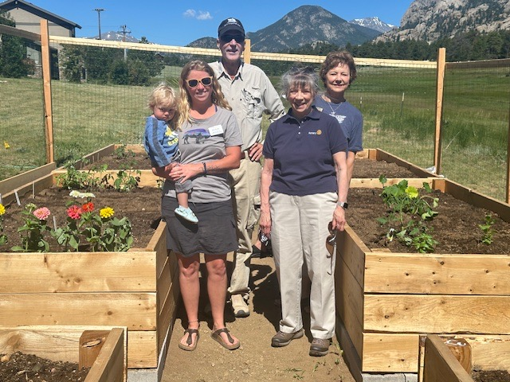

Figure : Jessica Moffett (EPHA Operations Manager), Ren Gobris (EVCG President), Annie Slack and Jean Rismiller (EP Rotary Club Presidents.)

1. In addition to the construction at Falcon Ridge, the Garden also replaced 6 aging ground level beds with newly constructed raised beds through our “Gardening Opportunities for Seniors Program.” Raised beds make it easier for seniors (those 65 and over) to garden. Also upgraded were the rotting foundations of 14 aging ground level garden beds. All the new construction included the novel EVCG innovation of cement block and gravel foundations that (so far) have proven to greatly impede the destructive impacts of voles, ground squirrels, mice, and pocket gophers.

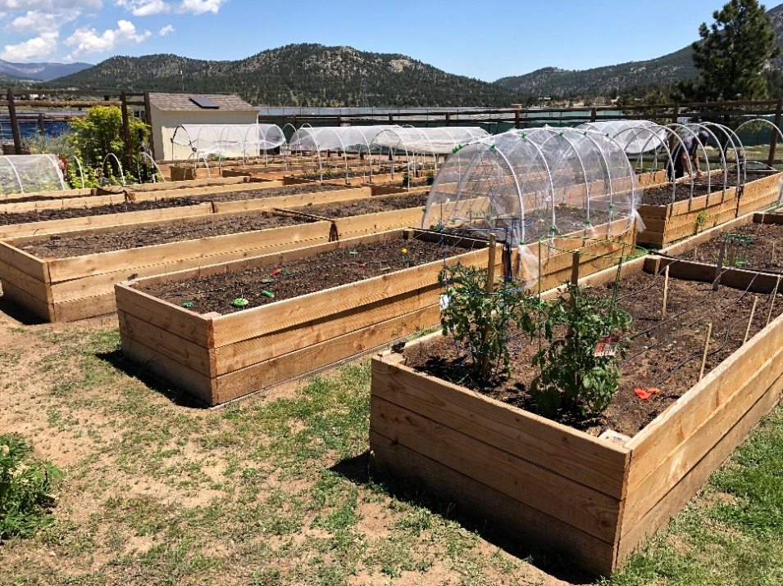

Figure : Newly Constructed Raised Beds at The Community Garden.

1. The Board applied for, and won, two grants. These included $4,000 from the Estes Valley Rotaries ($2,000 from each) and $5,485 from the Village Thrift Shop (VTS). The Rotary funds paid for the Falcon Ridge project (see above). The VTS funds paid for the construction of the above described 6 raised beds this past Spring and 14 ground level beds this past Fall. Two additional raised and ground level beds (2 each and 4 beds in total) are scheduled to be built in the Spring of 2025 prior to the start of the new growing season.
2. To reduce the workload at the Board level, and to provide the Board with routine monthly reports and more solid financial advice and services, a Finance Committee was established and meets monthly. A side benefit of the Finance Committee is that Board meetings have become more streamlined and future-oriented with financial discussions being limited to exceptional issues that require Board attention.
3. Gardeners who could afford it were asked to, (1) “Round Up” their garden plot fee to $100 to help support garden operations, or (2) Provide an additional donation to support low-income families. The request proved to be an overwhelming success with $2,300 being generously donated.
4. Several events were held to make the Garden more welcoming. These included:

* Conducting our orientation day in the garden as opposed to a traditional conference room setting. The event was very well attended and came complete with guest speaker, fresh baked goods, and coffee provided by Kind Coffee.
* The use of “communal plots” was introduced for everyone’s education, use, and enjoyment. This season 4 plots were set aside to grow a variety of tomatoes, peppers, zucchini, yellow squash, carrots, beets, and turnips which were shared by all who wanted them.
* A well-attended and delicious Potluck event was held to help gardeners meet each other and build their social networks; and
* A Fall Harvest Fest was held at the Garden complete with a buffet-style dinner, silent auction, and live music. The silent auction generated over $300 and was made possible by the generosity of a several local business owners including: Rocky Mountain Chocolate Factory, ACE Hardware, Park Supply, EVRPD (golf), (UPDATE AS NEEDED.) More social activities are being planned in 2025 due to the overwhelming success of these events.

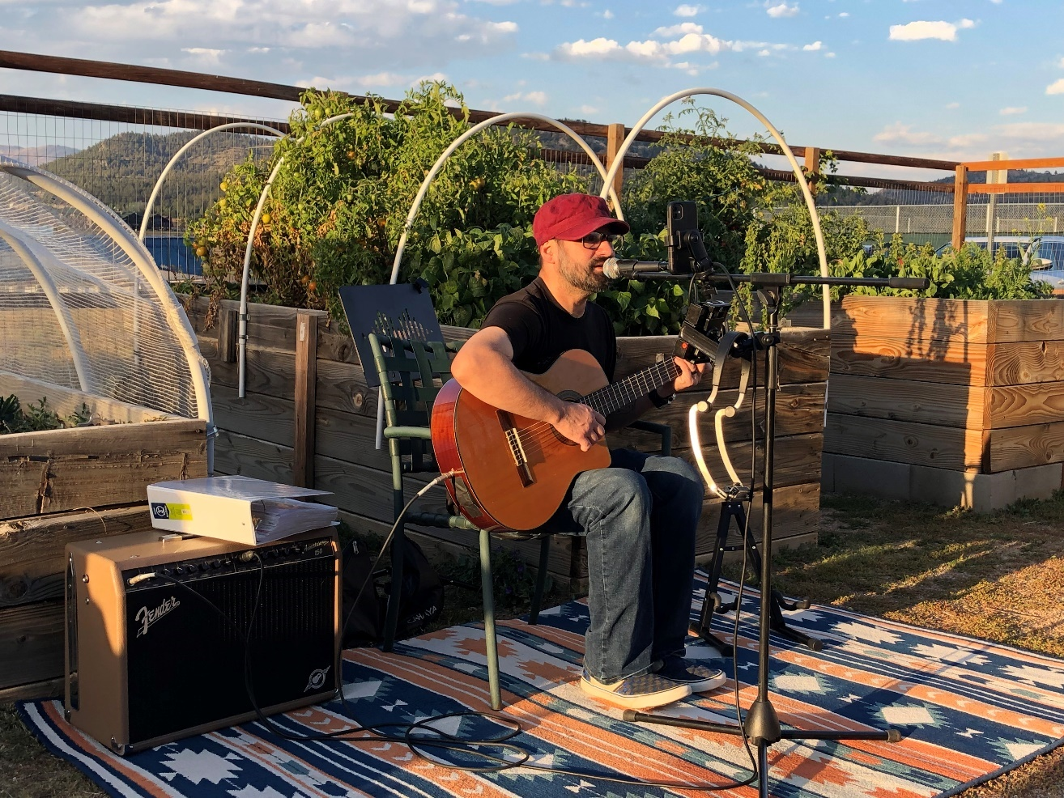

Figure : Live music was featured at the 2024 Harvest Fest

1. Four garden plots (up from 2 in 2023) were offered for the exclusive use of Crossroads Food Pantry to aid them in their mission of providing healthful food products to low income and/or food insecure people within our community.
2. The Garden sponsored 28 garden plots (approximately 30% of our plots) to low-income families. That was nearly double the number of plots that were sponsored in 2023 and was made possible by the generous donations of fellow gardeners as well as grants obtained by the Estes Park Rotary Clubs. The increase in sponsored plots has dramatically raised the relevance of EVCG in the community by giving low-income households the opportunity to participate in the many rewarding aspects of gardening.
3. For the first time, EVCG participated in the 2024 Duck Race that resulted in raising $552. That number isn’t especially high. But much was learned during the process, and the Garden is now positioned to better take advantage of the Duck Race as a future fund-raising tool.
4. Through our grant approval and construction process we’ve deepened our relationships with important Estes Park donors and volunteers. A total of 750 hours were donated by volunteers this year. A partial listing of our donors include: The Estes Park Rotary, EP Sunrise Rotary, the Village Thrift Shop, Estes Park Lumber, ACE Hardware, Park Supply, Affordable Tree Service, Estes Park Tire and Auto, The Newcomers Club, the YMCA Elevate Gap Program, Cave Cat Gardens, and dozens of Garden Member Volunteers.

Figure : Volunteers from the YMCA Elevate Gap Program

**Special Thanks:**

The EVCG Board would like to express special thanks to those who helped make the Garden a success over the past season. Among these are:

**Doyle Baker**, for directing our VTS Grant approval process and for his innovative raised garden bed design, ongoing irrigation maintenance, and Garden operations consultation. **Jim Redman,** for his unyielding commitment to the Finance Committee and for hours of almost singlehandedly working at pest control at the Garden. **Dave Boon,** for coordinating the various parties responsible for making his vision of the Falcon Ridge Project a reality as well as for untold hours of construction labor at both Falcon Ridge and the Community Garden. **Rod Stalder**, for his tractor work that saved countless hours of manual labor at both Falcon Ridge and the Community Garden. And finally, thanks are owed to **Ren Gobris** (past President and current Treasurer), for his strategic and operational leadership, without which many EVCG accomplishments simply would not have been achieved.

We also wish to express our heartfelt thanks to **Melanie** and The Estes Park Lumber Company for providing EVCG with discounts that greatly helped finance our 2024 construction projects. And we wish to express very special appreciation to the YMCA Elevate Gap program who provided over 500 hours of labor in completion of our projects. We quite literally could not have done these without the work of the YMCA volunteers.

Naturally, special thanks go out to the organizations and individuals that provided the funding for this years’ construction and operational efforts. These included the Village Thrift Shop, both Estes Valley Rotaries, the Estes Nonprofit Network, and many Gardeners and private individuals.

Finally, we’d like to thank the following people for their participation as Board members over the past two years but who have moved on for personal reasons and/or because they have served out their respective terms. Many of these people continue to support the Garden and Board but just no longer in an official capacity. We wish to recognize and honor them for their past and ongoing support.

**Claire Hanson**

**Doyle Baker**

**Kim Muench**

**Mary Sampson**

**Jim Bruce**

**Leslie Alexander**

**Neil Alexander**

**Clara Logue**

**What To Expect in 2025**

As successful as 2024 was, there is more work to be done. EVCG, like most other organizations, continually experiences leadership, operational, and financial issues. Recognizing this, the Board would like to call attention to the following three planned areas of improvement to help make the EVCG the best that we can be.

**Board Leadership Needs:**

Chief among the 2025 Garden priorities is a continuing need to recruit new Board members. Each Board member serves a 2-year term and 2025 will see the terms of three of the five current Board members expire this July. To prevent a detrimental vacuum of organizational knowledge and loss of continuity in leadership, it’s important that new Board members be recruited and become familiar with organizational needs prior to the departure of these anticipated vacancies.

It’s also important to recognize that our community garden operates on a 100% voluntary basis. Surely, not everyone is cut out to be a Board member. But the ongoing viability of the Garden as a going concern depends upon a competent and sustainable Board. New Board members not only fulfill organizational responsibilities, but they also provide new ideas and enthusiasm to have those ideas successfully implemented. New Board members prevent existing Board members from burning out. It is therefore vitally important that these roles be filled, and to ensure the long-term health of the organization, that an ongoing pool of potential replacement candidates be identified and maintained.

If there is something you don’t like about the community garden and/or have identified something you think can be improved, don’t keep it to yourself. Don’t just complain. Do something about it. Join our Board and help to make those changes a reality.

The difference between being a good community garden, as we are today, and becoming a great community garden of tomorrow, is largely dependent upon the dedication, creativity, and actions of those few individuals who unselfishly fill leadership roles. So, please help us fill our Board positions today!

**More Group Activities:**

We would like to build upon the success of the various activities that were done this year. The Potluck dinner, Harvest Fest, and even the various completed construction projects helped to strengthen personal relationships. They helped to create an atmosphere and culture of camaraderie and inclusiveness that goes well beyond simply gardening. These events helped like-minded individuals get to know each other a little better by taking their membership in the community garden to a higher social level. We’d like to have more of these types of events. They are not only enjoyable in their own rite, but they also help to strengthen the community that is the Estes Valley Community Garden.

**Ongoing Infrastructure Improvements:**

In a very difficult decision, garden plot rental fees in 2024 were raised to $80. This was done to safeguard against historical funds shortages as well as to provide financial resources to repair aging and crumbling infrastructure on a more predictive schedule. The rate increases no doubt reduced the number of 2024 returning gardeners. But the increase also put the Garden into more solid financial grounds enabling costly repairs and improvements to be made without the need to dip into the safety net of operational reserves.

Rates for 2025 have yet to be determined. But one thing is for sure. The year 2025 marks the 10th year anniversary of the Garden (9th actual growing season) and much of the infrastructure is original and beyond its expected life. It needs replacement.

The Board has been aggressively upgrading garden beds over the past few years. During the last two years, 32 ground level garden beds have been upgraded to raised beds. And, by Spring of 2025, sixteen additional garden beds will have had their foundations improved. In total then, 48 of our 91 garden beds (over 50%) have been upgraded in a very short period. Given our aging garden population, that is an impressive result. It was made possible by the heroic work of certain Board and ex-Board members, dozens of gardeners, and many outside organizations and individual volunteers.

We hope to acquire funding to continue our infrastructure improvement plans. And with that, we’ll need the continued support of individual gardeners to provide the labor to make the plans a reality. We’ll keep you updated on our financing progress and look forward to continuing our improvement efforts with each of you. We thank you in advance for your continued support and cooperation because, once again, VOLUNTEERS CREATE THE COMMUNITY THAT IS OUR COMMUNITY GARDEN!

**2024 Financials:**